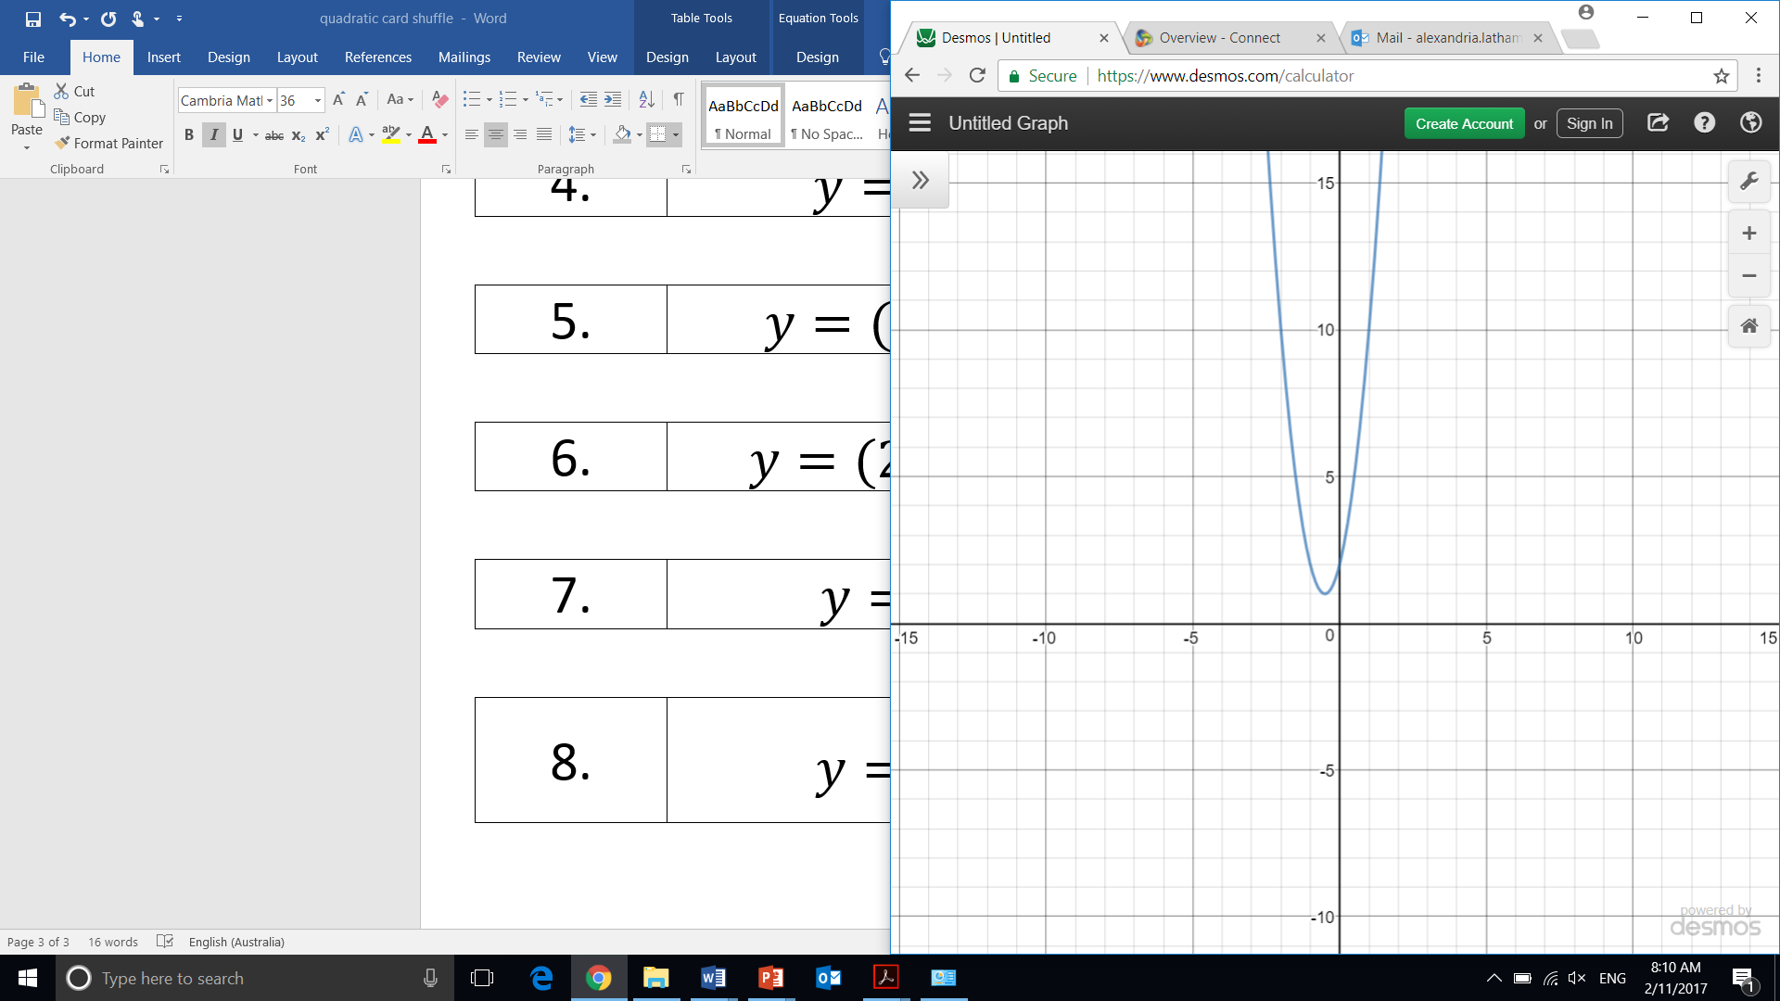 |  | 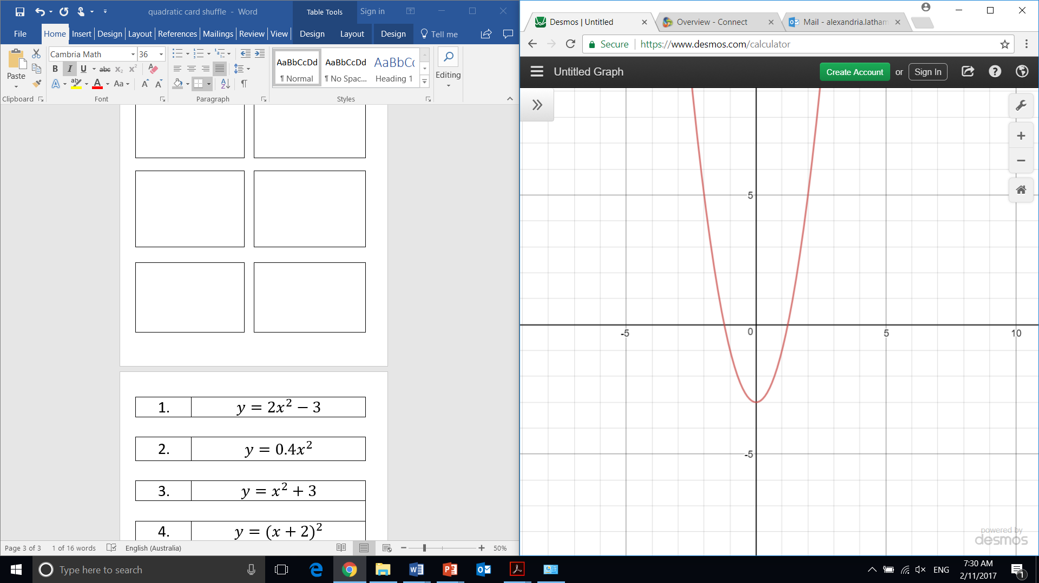
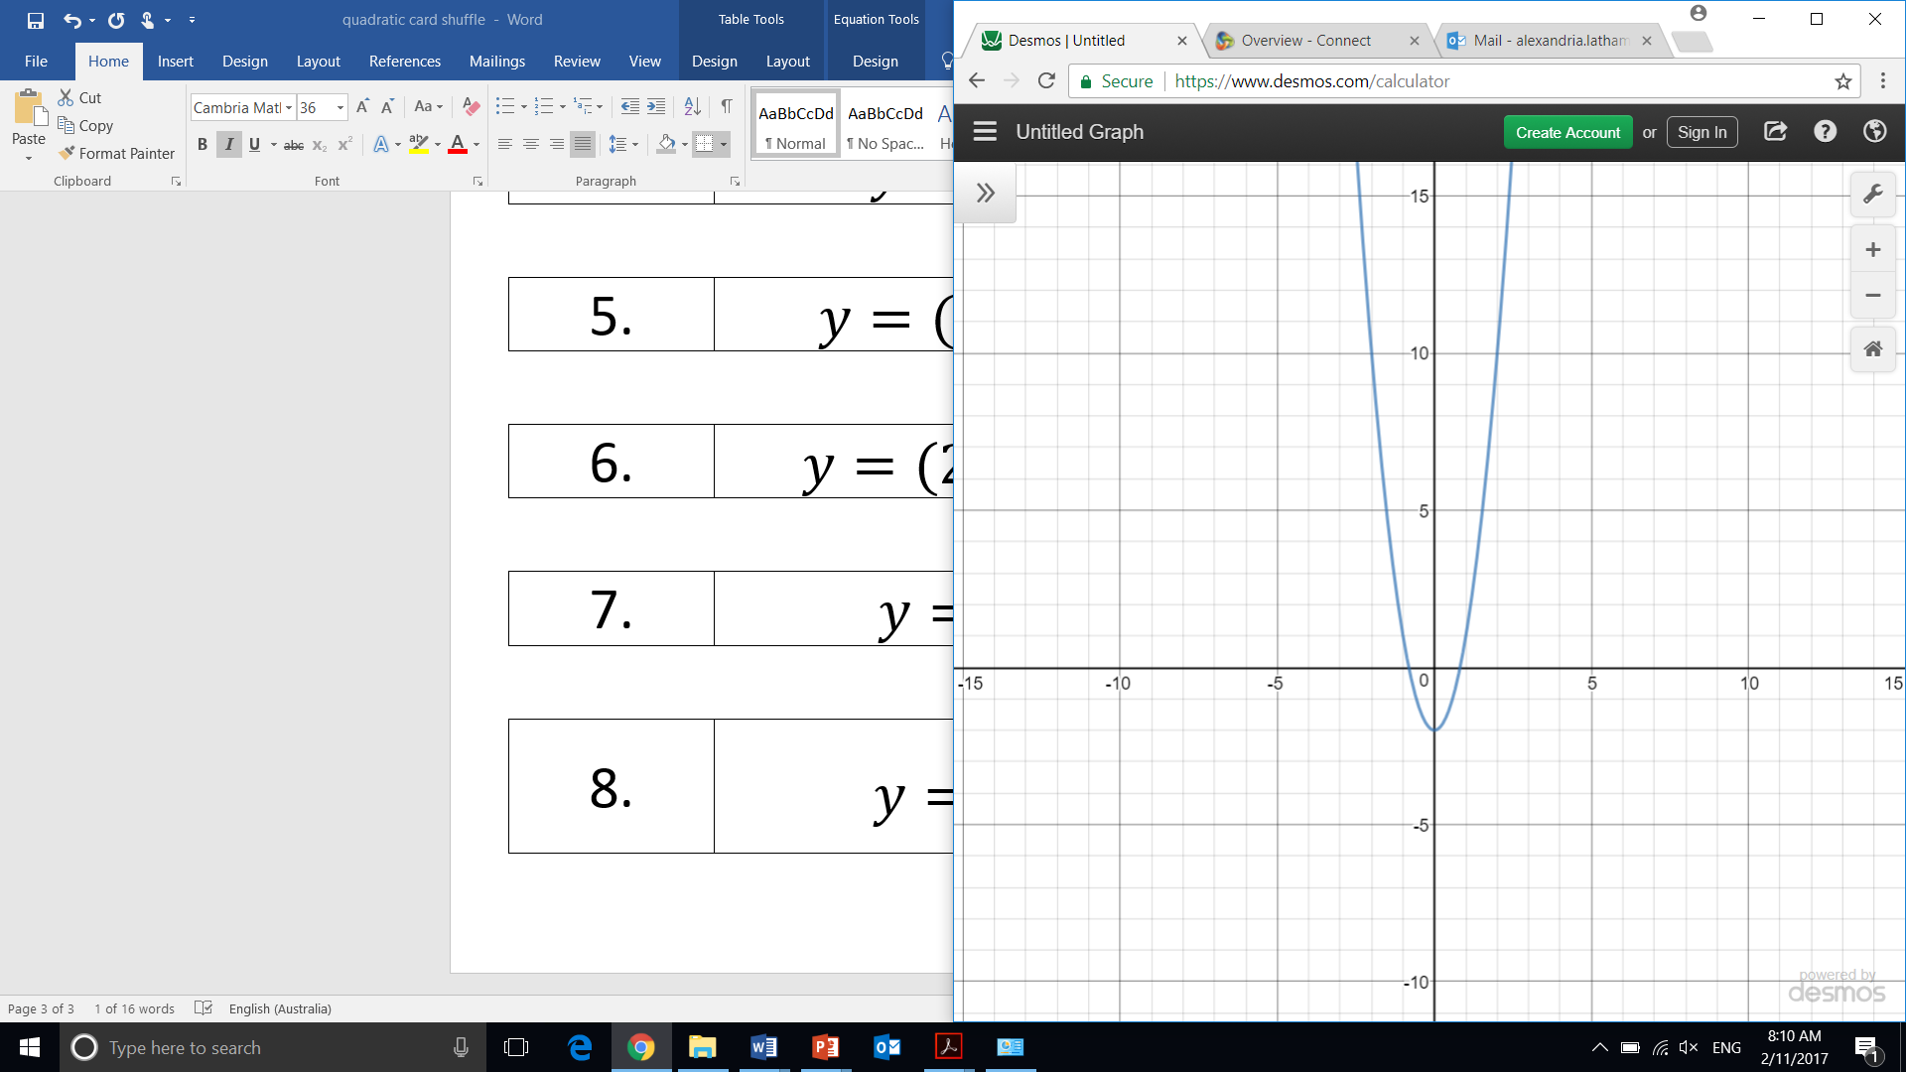 |  | 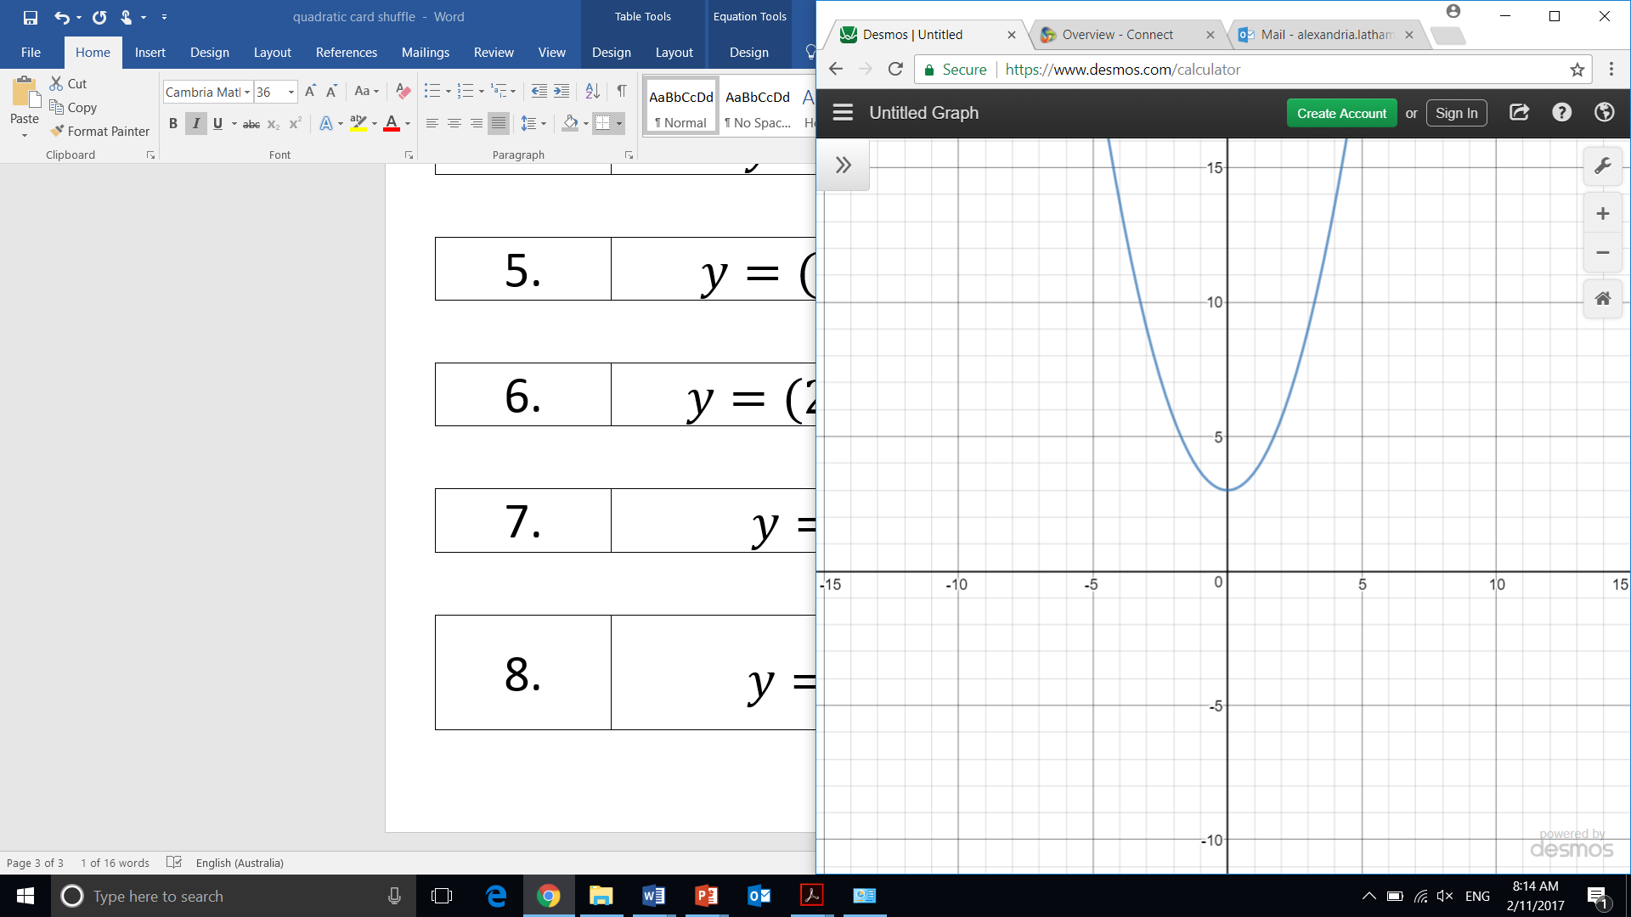
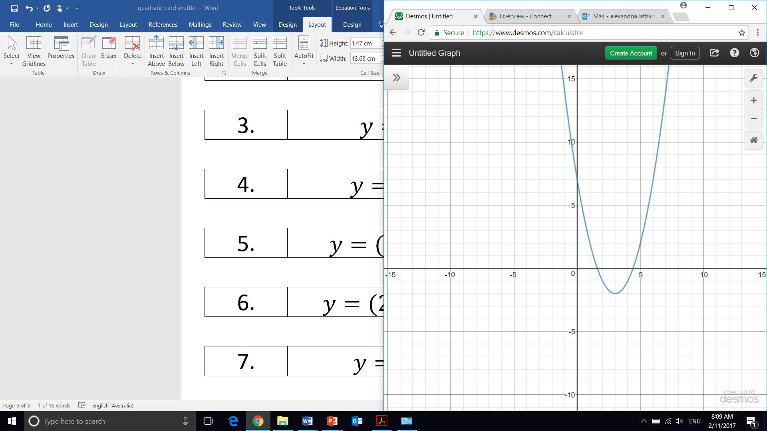 |  | 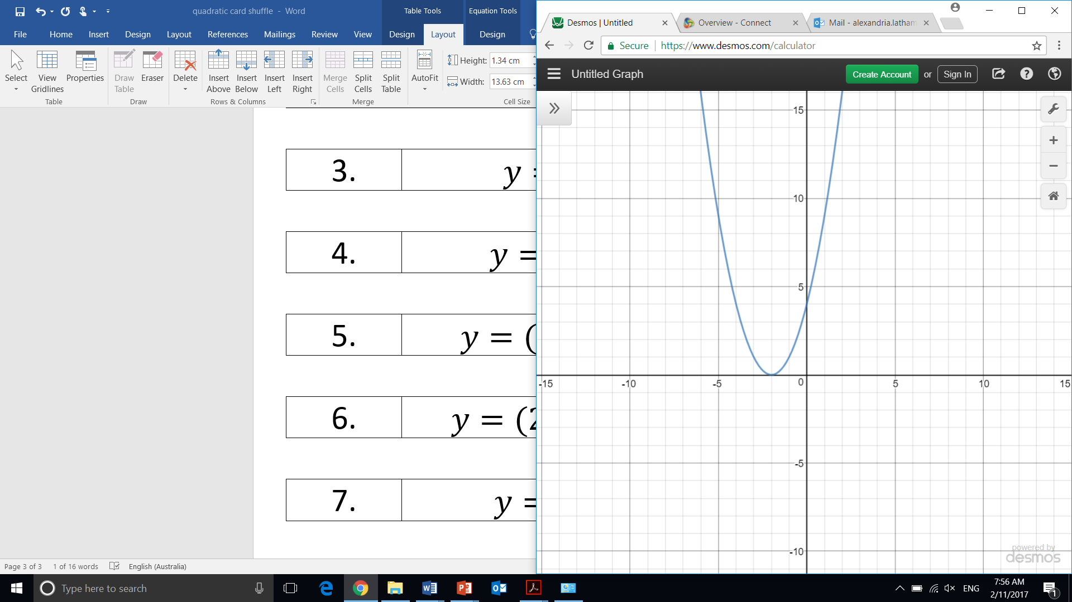
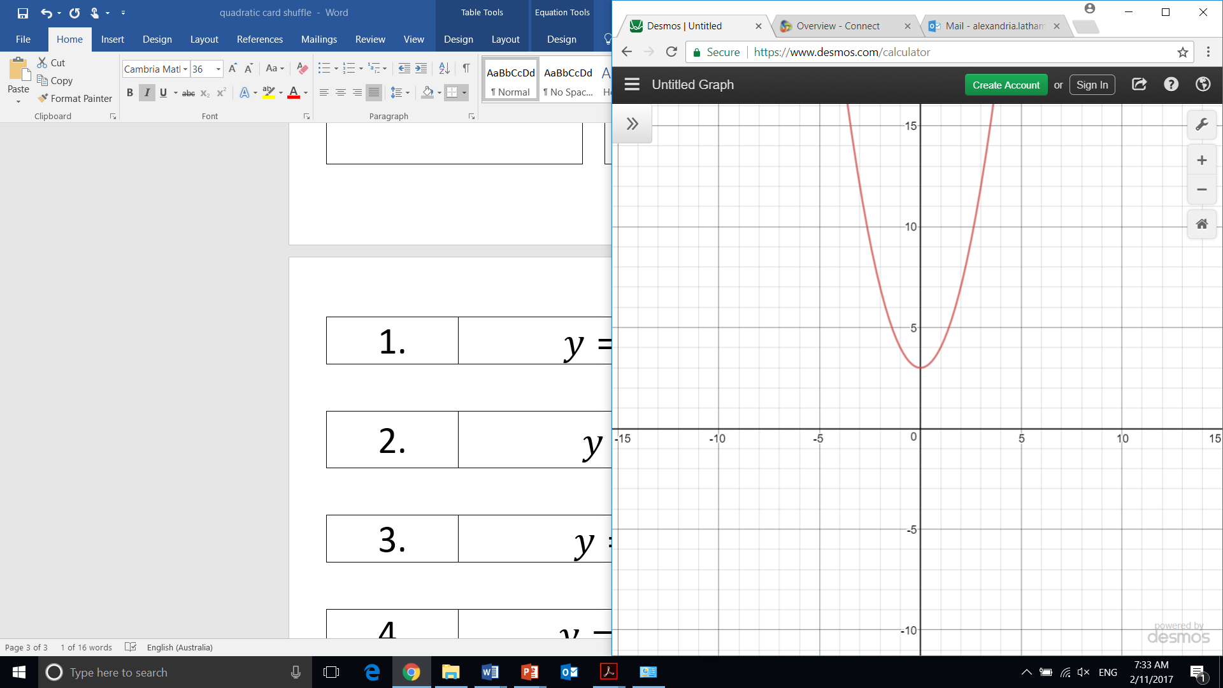 |  | 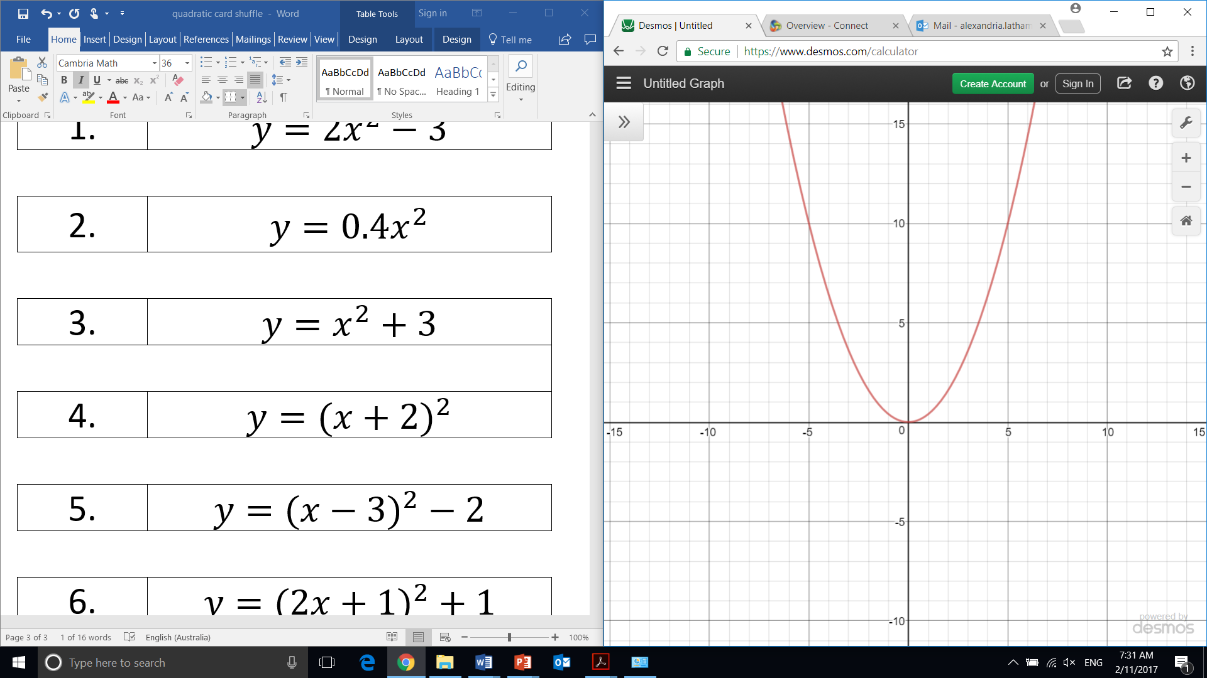

1. | $$y=2x^{2}-3$$
2. | $$y=0.4x^{2}$$
3. | $$y=x^{2}+3$$
4. | $$y={(x+2)}^{2}$$
5. | $$y=({x-3)}^{2}-2$$
6. | $$y=({2x+1)}^{2}+1$$
7. | $$y=3x^{2}-2$$
8. | $$y=\frac{2}{3}x^{2}+3$$

